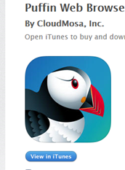

We are pleased to share that Compass Learning Odyssey® is now accessible from virtually any mobile device, including iPad/iOS and Android.

In order to access Odyssey content from your mobile device:

1. Go to the App Store for your mobile device and find Puffin Academy by CloudMosa.

2. Download the Puffin Academy App (not the Puffin Web browser, also by CloudMosa).

3. Open the Puffin Academy App.

4. Find the Compass Learning icon and click it. A simple search for "compass learning" will bring you to Odyssey.

5. Click the Compass Learning logo, then click the logo again, and you will be redirected to the Odyssey login screen.

6. Log in as you normally would and begin using Compass Learning Odyssey.

We hope you enjoy the flexibility of accessing Compass Learning Odyssey from your mobile devices. Please visit the support community for questions and further information regarding this exciting announcement.